Lewisville LIONS News
P.O. Box 292222, Lewisville, TX 75029-2222 www.lewisvillelions.org
May 2018

Musings of the President

Spring is well underway, and our activity level is starting to ease up a bit. As we approach the end of this current Lion Year, I encourage you to take time to reflect on our successes this year. We’ve accomplished a lot, including two successful fundraisers, Feed the Firefighters of Lewisville, multiple vision screenings, Fox Creek cleanup, and much more. Please give some thought to how we can improve our service to the community. I’d love your input as we start planning for the 2018/19 year.

Our guest speaker on May 22 will be PDG Jan Carrington, director for the District 2-E2 Eyeglass Recycling Center. Please join us that evening and give him a warm welcome. This is a great opportunity to invite guests who may be interested in volunteering or using the donated glasses for mission trips.

Speaking of inviting guests, the District has just launched a new membership drive contest. You have a chance to win up to $250. Look for additional details in this newsletter.

Be sure to mark your calendar for our officer installation dinner on June 26. Lion Jane Schoknecht and her husband, Bill, have graciously offered to host the dinner at their home. We’ll induct our 2018/19 officers, announce our LION of the year recipient, and eat some BBQ. This is a family event, so bring your spouse (and kids) and join us for an evening of food and fun.

- LION President Brian
District Convention Results
LION Mary Ellen Layland of Cleburne was voted in as the 2nd VDGE at the District Convention. For more information see the district 2-E2 website www.lions2e2.org.

District 2-E2 Membership Contest
Every Lion that brings in a new member from May 1st to June 30th will have a chance to win one of four $250.00 gift cards or one of six $100.00 gift cards. If you bring in 10 new members you will have 10 chances to win. The drawing will take place at the Cabinet Meeting on July 21st.

Monthly Vision Screenings Continue at the Lewisville Library
Tell your friends, the LIONS conduct monthly Vision Screening at the Lewisville Library the last Sunday of the month from 1:30 p.m. to 3:30 p.m. Our next screening is May 27th. We need volunteers to conduct the screening. LIONS Tom & Karri will be unavailable. Please contact PDG Tom Hayford if you can cover the Sunday screening.

Installation Dinner
The annual Officer Installation dinner will be held at the Schoknecht’s home in Little Elm on the lake Tuesday June26th.

LION of the Year
Don’t forget to send your vote to Carlisle Engraving by June 16th for the Lewisville LION of the year. Email your nomination to sales1@carlislesengraving.com.
Expanding our Eyeglass
Collection Sites
On May 15th, we handed over the Flower Mound Eyeglass collection locations to the Flower Mound New Century club. That will allow us to identify more location within Lewisville. Consider asking your place of worship whether they would allow a collection box.
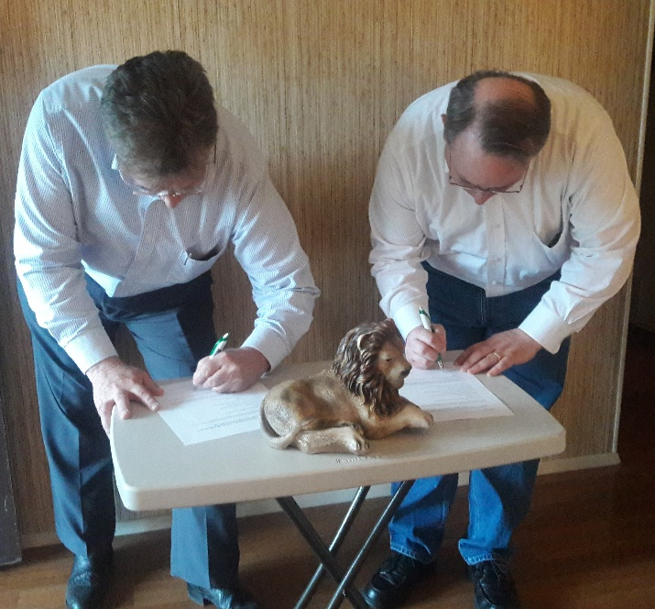

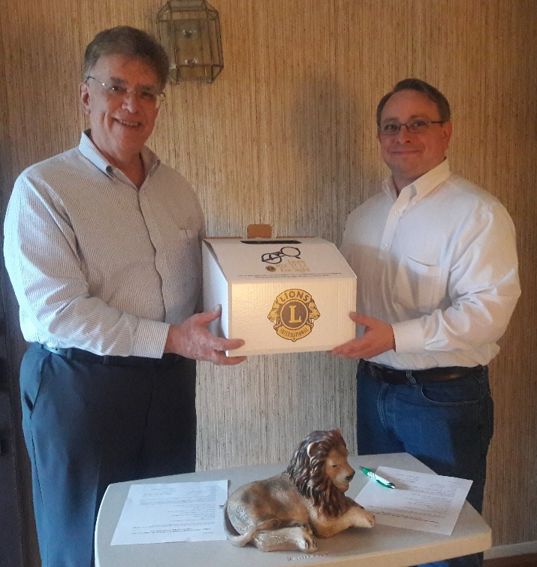

Put our SPOT to Use
If you know somewhere we can conduct a vision screening let us know. Have SPOT will travel to church, home school groups. We are willing to make house call too!
Salvation Army Vision support
Based on the screening done in April, we will be providing the Salvation Army 7 America’s Best certificate for their clients.

New MyLion App
Add the MyLion app to your Apple or Android device for easy access to club activities and reporting service hours. Connect with Lions just about anywhere. To download the app, go to mylion.org, or visit the Apple or Android app store.

Service Activity Reporting Change
Beginning in July, reporting community service activities will be made through the MyLion app instead of through the MyLCI program. More details to follow.

Fall LISD Back to School Event
The LISD school nurses have asked us once again to participate in the annual Back to School vision screening on August 4th, running from 9 a.m. to 2 p.m. Working with the nurses, we will run up to three lanes for screening children throughout the event.

Planning Underway for a Service Organization Open House
We are in the initial steps of planning a Fall open house for Lewisville service organizations to be sponsored by the LIONS. If you would like to be part of the planning team, please contact Lion Barb Lamkin.

Member Updates
Lion JB Hartgraves has an updated email address: R94859@gmail.com. Please note the change on your Member Directory sheet.

Lion Teri is doing well following her back surgery in April. Please give her a call or send her an email of encouragement.

If you have updates, please let the Lion Secretary know so they can inform the club.

LION Barb suggests you check out the following web site… a great business
https://twoblindbrothers.com/
Lewisville Lions Officers
2017-2018
- President Brian Marvel
- Secretary David Jones
- Vice President Shirley Coleman
- Treasurer Don Riley
- Directors
  - Jane Schoknecht 2017-2018 one-year director
  - Carl “Pops” Lunsford 2017-2019 two-year director
- Lion Tamer Tom Hayford
- Tail Twister Barb Lamkin

Lewisville Lions Officers
2018-2019
- President Brian Marvel
- Vice President David Jones
- Secretary Tom Hayford
- Treasurer Karri Hayford
- Directors
  - Jane Schoknecht 2018-2020 two-year director
  - Carl “Pops” Lunsford 2017-2019 one-year director
- Lion Tamer Tom Hayford
- Tail Twister Barb Lamkin
- LCIF club representative Barb Lamkin
- Club Service Coordinator Stacie Anaya

Eyeglass Recycling Collection Locations!!
Thanks for your continuing support of our eyeglass recycling collection locations. Our current Lewisville locations are:
- TSO MainStreet, Lewisville
- The Hair Studio, McGee Lane
- Costco, Lewisville
- Landmark Grill on FM 407
- Sharp Eyes, 2410 S Stemmons (on the side of Toys R Us), Lewisville
- Lewisville Senior Activities Center
- First Baptist Church
- America’s Best on FM 3040
- Dr Batani on FM3040

We Make a Difference Every Day in Lewisville!!
Here is a listing of the coordinators for various on-going activities.
Youth Eyeglasses with LISD: LION Karri Hayford
Adult Eyeglasses: PDG Tom Hayford
Used Eyeglass collection and Recycling: LION Teri Garcia
Texas LIONS Camp: LION Karri Hayford
World Services for the Blind: PDG Jim Coleman
Red Kettle Campaign: LION Carl Lunsford
Membership: LION David Jones
Web Site: LION Brian Marvel
Newsletter: PDG Tom Hayford

Some Interesting Web Links
- LIONS International: www.lionsclubs.org
- Texas MD-2 LIONS www.texaslions.org
- District 2-E2 LIONS: www.lions2e2.org
- District 2-E2 Organ and Eye Bank: www.loeb2e2.org
- District 2-E2 ERC: www.2e2erc.org
- Texas LIONS Camp: www.lionscamp.com
- Leader Dog for the Blind:
- www.leaderdog.org
- World Services for the Blind:
- www.wsblind.org
- To sign up for organ donation: www.donatelifetexas.org
- Access to eye related financial support for seniors: www.eyecareamerica.org
- Denton County Habitat for Humanity: www.hfhdentoncounty.org
- Lewisville LIONS Facebook: www.facebook.com/Lewisvillelions
- Lewisville LIONS Twitter @LewisvilleLion

Wear your LIONS pin. It’s a GREAT way to start a conversation!

